Using Sailwave to Score NSYA Race

April 2009, NSYA

Table of Contents

- Introduction to Sailwave

- Installing Sailwave software

- Loading your first race

- Entering Race Data

- Entering Competitors

- Scoring the race

- Publishing to web

- Creating a Series

- Submitting results to NSYA

- Access denied

Sailwave

Sailwave is a comprehensive Race Scoring software that is available free of charge from www.sailwave.com. This software is in use Worldwide and is continually updated. It is the most widely used race scoring software available today for sailboat racing.

Installing Sailwave Software

Sailwave software can be obtained free of charge from the Sailwave website at www.sailwave.com under the “downloads” tab. Install using the default options.

Loading your first Race

NSYA has provided a template file NSYA_Template.blw that contains all current NSYA vessel handicaps. Copy this file and rename to something meaningful and be sure to retain the .blw file extension. Ex. BBYC_opening_A.blw for the Bedford opening regatta for A class. Double click on the renamed file to start Sailwave.

Entering Race Data

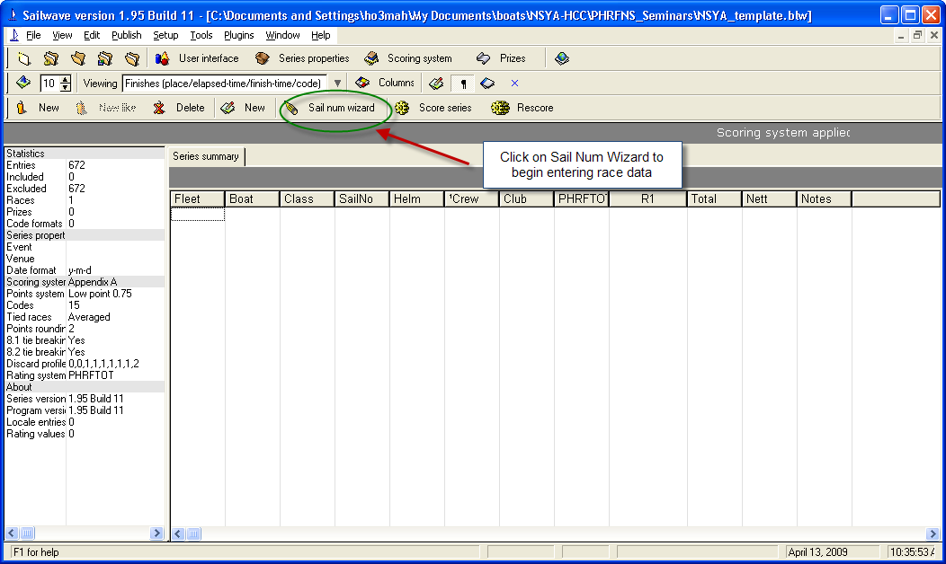

The above screen will display once you have opened the copied file (ex. BBYC_opening_A.blw). To begin entering Race data we click on the Sail Num wizard as shown above.

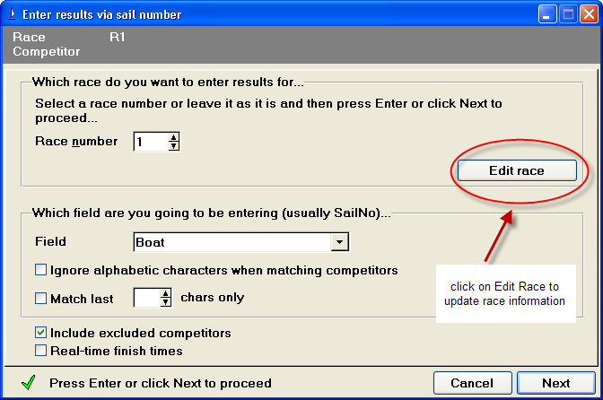

The Sail Num wizard displays the screen shown above. Click on “Edit Race” to input information about the race being scored.
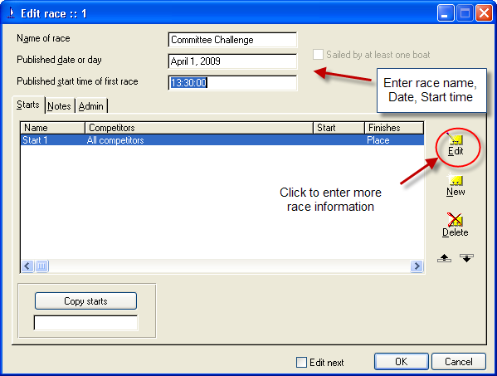

In the Race Edit screen input the name, date and start time and then click on EDIT to input more detailed race information as shown below.

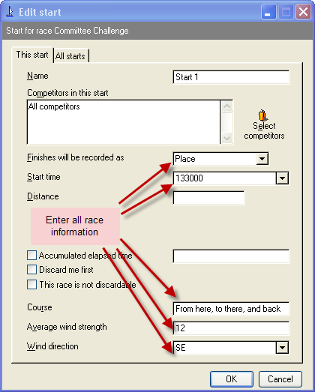
To Enter the competitor boats and times you can select by Sail Number or by Boat. Since not all NSYA boats have listed Sail Numbers it is easier to select by Boat.

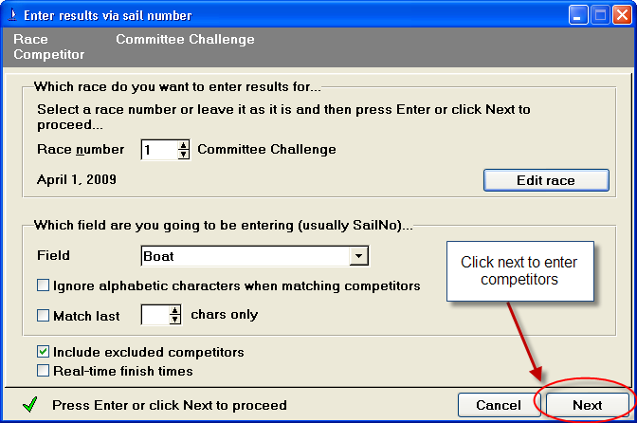

For each competing boat enter enough letters in the boat name to make it unique. All NSYA boats with the same starting letters in the name will be displayed. Either click on the boat in the list or enter enough letters to make the boat unique and press ENTER.

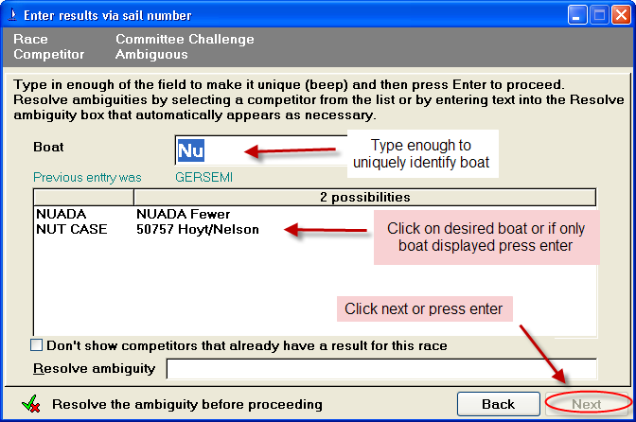
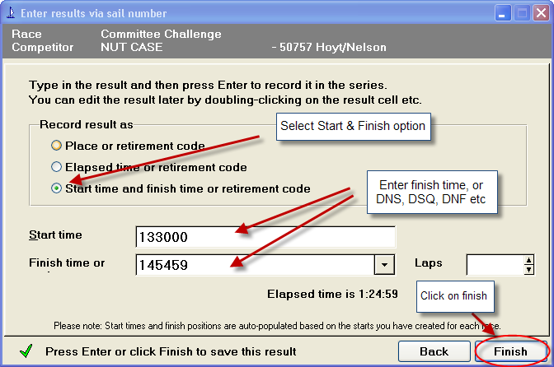

The time can be entered as HH:MM:SS or HHMMSS. In this example we have selected Start Time and Finish Time. If you have entered Start Time on the first boat or for the race you need only enter Finish Time.

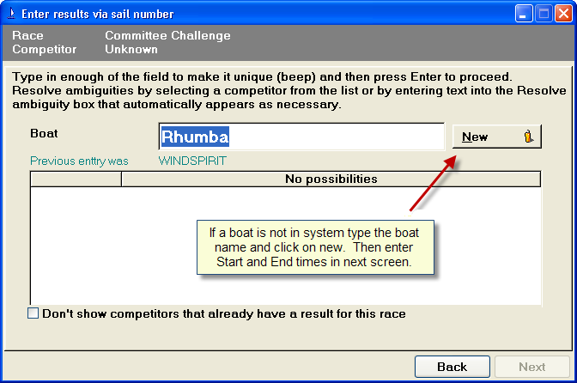

If the boat is not in the Sailwave database then enter its name and Click on the NEW button. You can enter more information on that boat later.
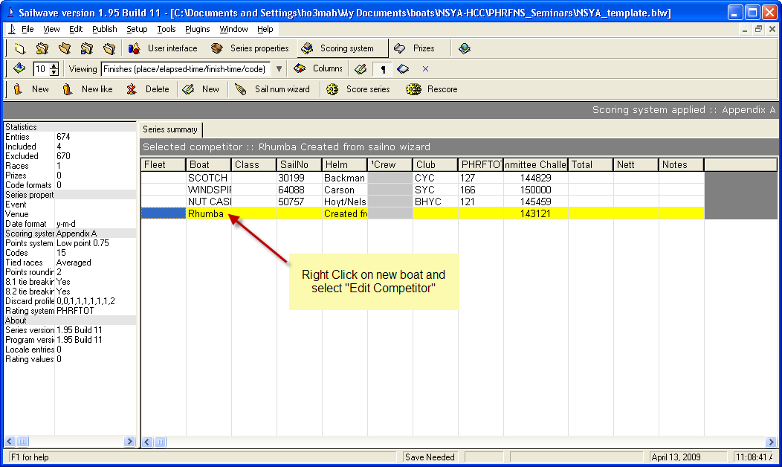

To enter more information on the NEW boat highlight the boat’s entry, then right click on it and select EDIT COMPETITOR.

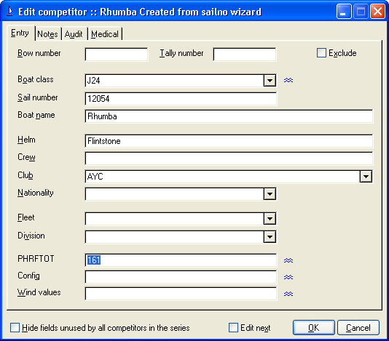

Enter all relevant information concerning this new boat. Note that PHRFTOT is our NSYA supplied race rating.
Scoring the Race

To score a race using Sailwave click on the SCORE SERIES button. TheNSYA supplied sample race will have the scoring system already defined as PHRF Time on Time with default A and B factors of 695 and 525.

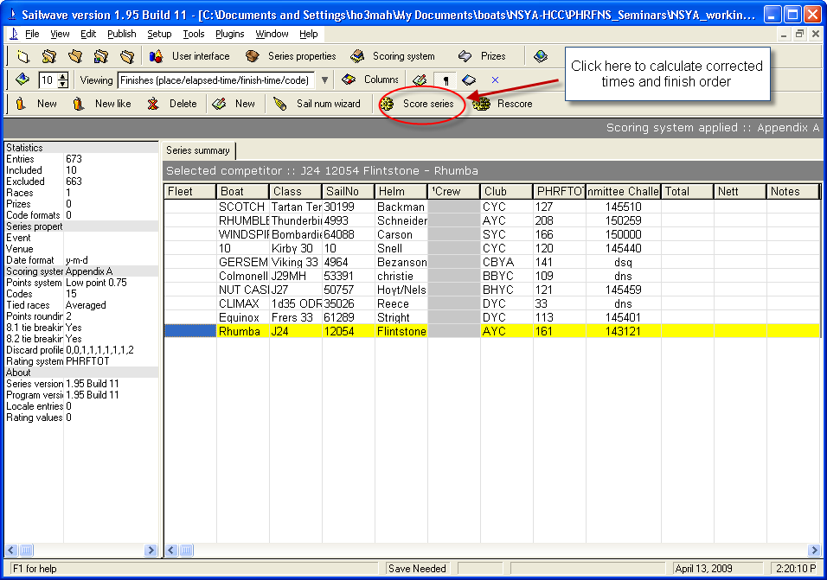

Once scored you need to select CORRECTED TIMES from the viewing pull down menu to see the corrected times.

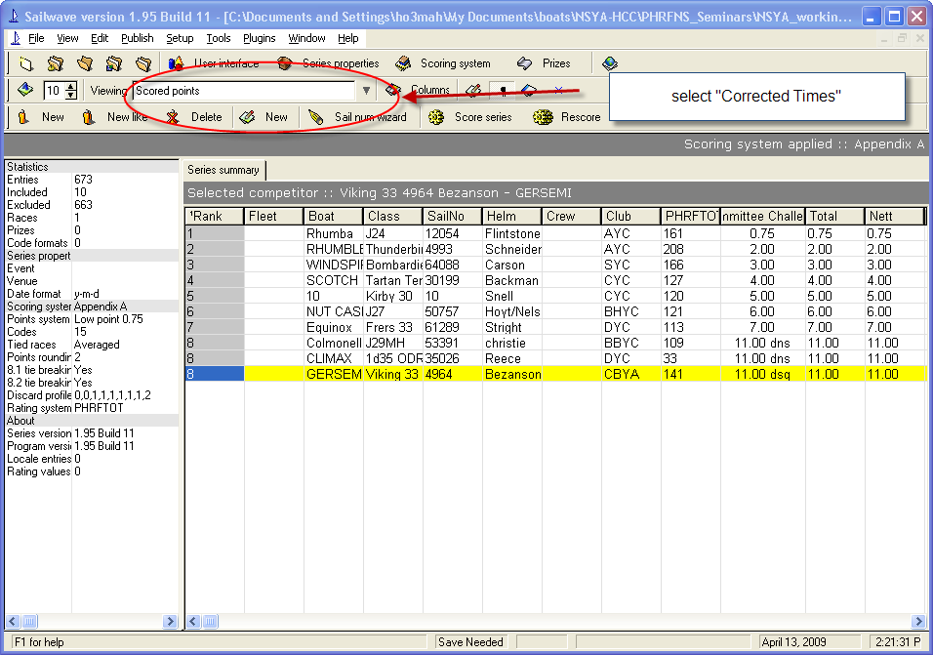
The final result is now displayed complete with calculated points, placings and corrected times.

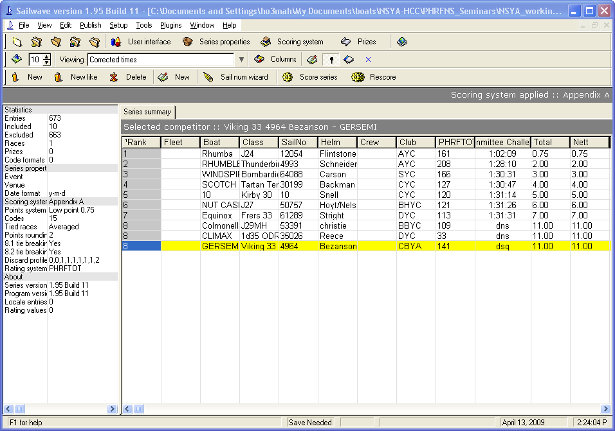
Publishing to Web

Sailwave will publish results as an HTML file in the same manner as Winregatta and other products. Once the file has been created send it to your Webmaster to have published on your web site.

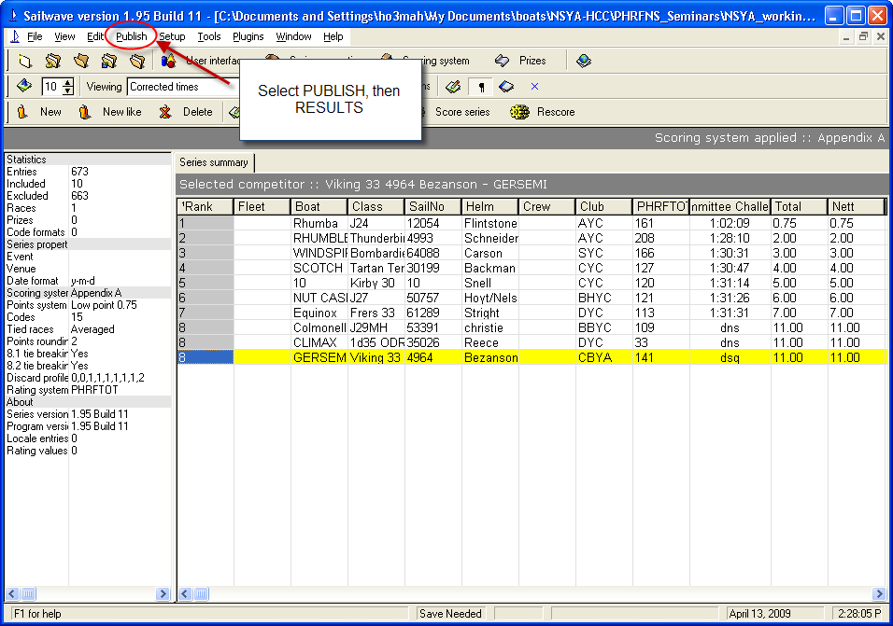

Select the PUBLSH menu and select RESULTS. In the next screen select which race to publish and a Title.
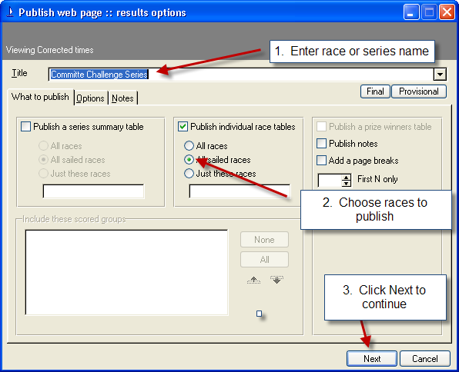
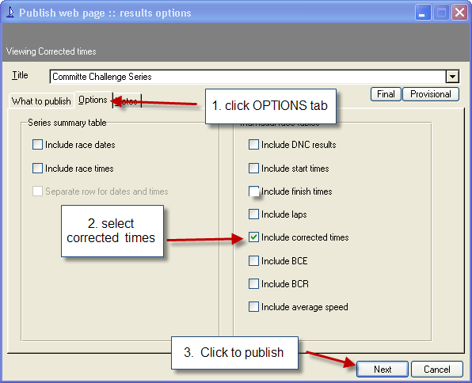

Next click on the OPTIONS TAB to ensure Corrected Times are included and press NEXT to select publish to web browser or file, and then file name.

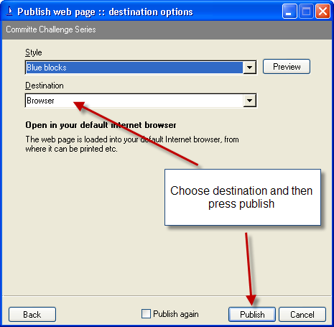
The published results will look similar to the following on your web page.

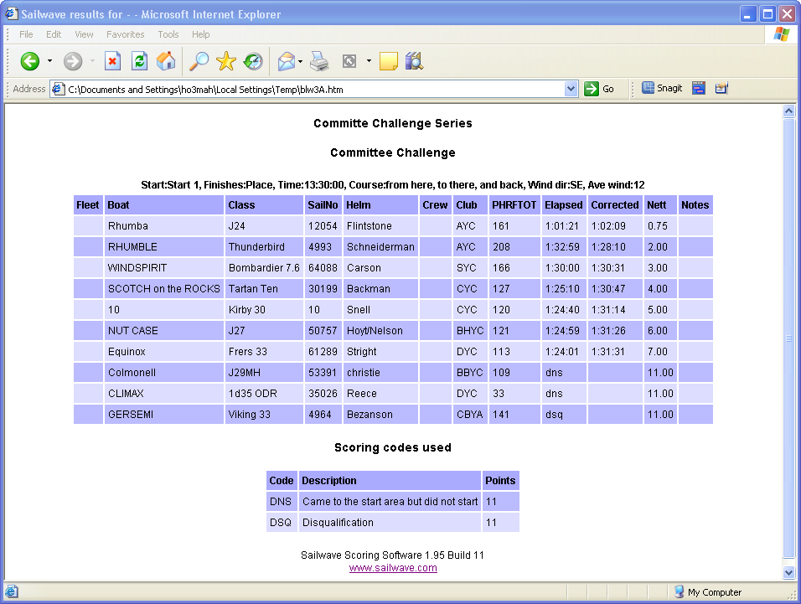

Creating a Series using Sailwave

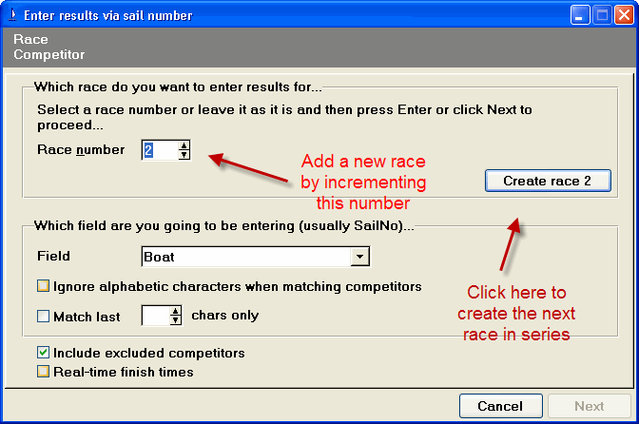

To add a new race to an existing series or to create a series out of a Sailwave file that contains a single race click on the SAILNUM WIZARD and the box shown above will be displayed. Increment the Race Number as shown above and then click on the CREATE RACE button.

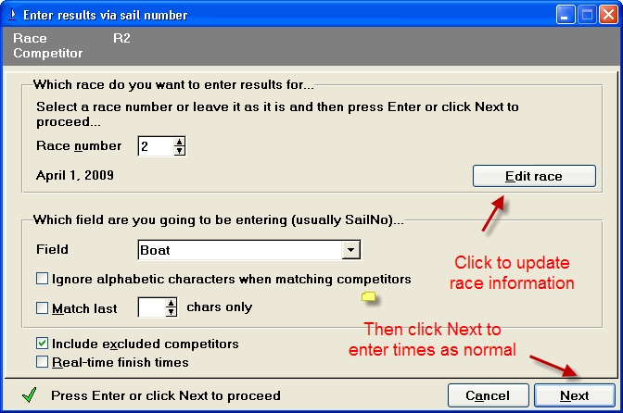

Once you have clicked on CREATE RACE ## the new race has been created in your Sailwave file. Click on Edit Race to enter details about the race such as name of race, course, wind conditions, date and start time. Then click on Next to enter the times or codes for each boat in the race.
Submitting Results to NSYA

The Nova Scotia Yachting Association requests that results from Open Regattas be submitted to NSYA for handicap review purposes. When submitting results from Sailwave please submit the Sailwave file with the .BLW file extension rather than HTML files or printouts.

Access Denied

Occasionally the message “Access Denied” is displayed when attempting to open a Sailwave file. This usually occurs when someone has emailed or otherwise transferred the file and is caused by a Read Only attribute being set on the file.

To avoid this message always SAVE any Sailwave files to disk before attempting to open. You will always receive this error if attempting to open directly from an email.

To remove the problem on an existing file Right Click on the file and select Properties. Under the General tab at the bottom of the screen is a Read Only check box. This needs to be blank. If checked clicjk on this to remove the Read Only attribute and click OK.

